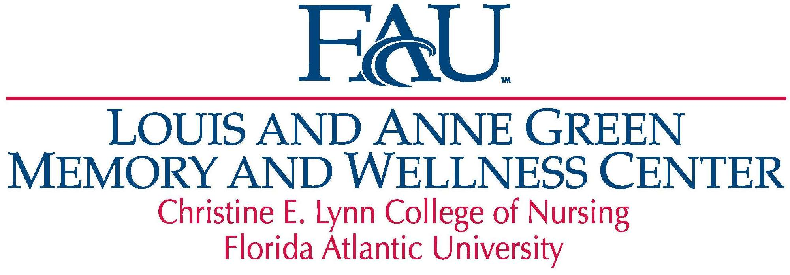

**Adult Day Center**

**November 2024 Calendar**

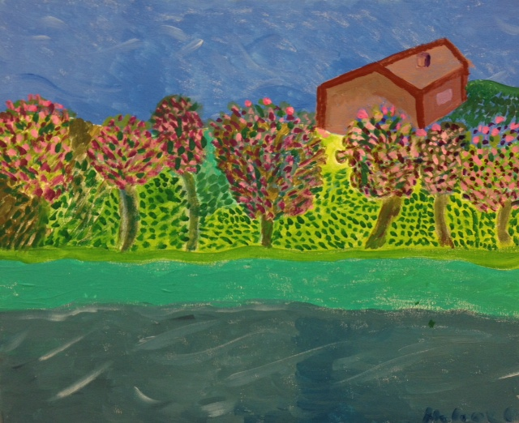

** This artwork was created by a Day Center participant. Paintings, as well as note cards created from participant artwork, are available for sale. Proceeds help support the art programs at the Day Center. **

777 Glades Road Bldg. AZ 79, Boca Raton, FL 33431

Phone: (561) 297-0502 ▪ Fax: (561) 297-0505

Email: memorylane@health.fau.edu ▪ Web: www.fau.edu/memorywellnesscenter

**Description of Monthly Activities**

**Remember That Entertainer:** In an ongoing program, participants will discuss biographical trivia and sing along to specific artist’s greatest hits.

**Celebrity Birthday Bios:** Monthly program that rounds up celebrities who have birthdays in a given month.

**Creative Arts:** Creative expression activities including Painting, Watercolors, drawing, adult coloring, card making, stencil creations, roller art, salt art, flower arranging, and other artistic expressions.

**Discussions:** Topic and information presented by staff; participants called on to illicit conversation and discussions.

**Lecture:** Staff presents information using PowerPoint and speaking ranging in a variety of topics and genres, including events, travel and popular culture.

**Music Requests**: Participants request songs, entertainers, or specific genres

**Music with Todd:** Friday afternoons music, dancing and entertainment with musician Todd.

**Table Games:** Socializing and cognitive stimulation through games, including cards, jigsaw puzzles, Dominoes, “Roll the Dice”, Bingo (traditional, geography, music and songs), Qwirkle, Sock Matching, Jenga, Connect Four, Scrabble, and Banana Grams.

**Tossing and Movement Games:** Group activities to encourage socialization, cognitive stimulation and physical activity, including Corn Hole Toss, Ping Pong, Balloon Volleyball, Ring Toss, Bean Bag Toss for Points, Jackpot Ball Toss, Basketball toss, Scarf dancing, Paddle games, Bike pedals, Magnetic dart board, and Parachute Challenge.

**Trivia and Reminiscing Programs:** Geared towards stimulating memories including a variety of topics and interests.

**Word Games:** Question and answer sessions to focus on word finding and problem-solving; programs include Finishing Lines and Lyrics, Finishing Words, Cliché’s & Idioms, Spelling Bee, Vocabulary Power Plus, Rebus Puzzles, Homonyms, Word Searches, Crossword Puzzles, Boggle, Scattegories, “Words within Words”, Hangman, Words that start with…, The Things Game, Letters and Lists, Why do we say it, and Have a Word, Make a Sentence.

* Additional activities may include pet therapy, live entertainers, and much more.

|  |  |  |  |  |
| --- | --- | --- | --- | --- |
| **Monday** | **Tuesday**  **November 2024** | **Wednesday** | **Thursday** | **Friday** |
| 614,300+ November Stock Photos, Pictures & Royalty-Free ... |  | **C:\Users\blaket\AppData\Local\Microsoft\Windows\Temporary Internet Files\Content.IE5\8NE5AOSD\MC900019670[1].wmf** |  | **1**  9 Coffee, News, and Views  10 Commercial Jingles/ Balloon Volleyball  11 Chair Yoga/ Trivia/ Memory Magic  12 Lunch  1 Painting/ Sing A Long/Trivia  2 Music with Todd / Snack @ 2:30  3 Geography BINGO |
| **4**  9 Coffee, News, and Views  10 Painting with Barry  11 Johnathan Winters Program  12 Lunch  1 Song Lyrics Hangman  2 Chair Exercise  3 Social Hour/Table Games/Snack | **5**  9 Coffee, News, and Views  10 Dean Martin Live! / Creative Arts/Billiards  11 Veteran’s Day Program  12 Lunch  1 Music with Phil Stevens  2 Military and American History Trivia /Snack @ 2:30  3 Chair Yoga/ Discussion | **6**  9 Coffee, News, and Views  10 Creative Arts  11 Broadway Sing A Long  12 Lunch  1 Painting/Post Election Discussion  2 Consider This…. /Snack @ 2:30  3 Chair Exercise | **7**  9 Coffee, News, and Views  10 Explore California/Origin of the Teddy Bear/Billiards  11 Letters & Lists /” Table Topics” Discussion  12 Lunch  1 Patriotic Trivia/Painting  2 Spelling Bee/Snack @ 2:30  3 Chair Exercise/Discussion | **8**  9 Coffee, News, and Views  10 It All Happened in November  11 Chair Yoga  12 Lunch  1 Boggle  2 Music with Todd/Snack @ 2:30  3 Music Bingo |
| **11**  **Center Closed**  **(Veteran’s Day)** | **12**  9   Coffee, News, and Views  10 Sandwich Reminisce / Creative Arts  11 Free Rice Game  12 Lunch  1 Music with Stan  2 ElderSong Sing Along /Snack @ 2:30  3 Chair Yoga/ Discussion | **13**  9 Coffee, News, and Views  10 Conversation Starters  11 Outdoor Adventure  12 Lunch  1 You be the Judge **/** Painting  2 Boca Garden Club / Snack @ 2:30  3 Chair Exercise / Quiz Mania Trivia | **14**  9 Coffee, News, and Views  10 Remembering the Decades  11 Sports Discussion and Trivia /Creative Arts  12 Lunch  1 Art Garfunkel Program / Painting  2 Anagrams/Snack @ 2:30  3 Chair Exercise/Discussion | **15**  9 Coffee, News, and Views  10 Celebrate Dick Clark  11 Chair Yoga  12 Lunch  1 Painting with Barry/ Sing A Long!/Trivia  2 Music with Todd / Snack @ 2:30  3 Thanksgiving Memories /Scarf Dance |
| **18**  9 Coffee, News, and Views  10 Painting with Barry  11 Remember that Entertainer?  12 Lunch  1 Music with Ken  2 Chair Exercise  3 Family Feud/Snack | **19**  9   Coffee, News, and Views  10 Personal Ponies  11 Jeopardy  12 Lunch  1 Busch Wildlife Presentation  2 Outdoor Social/Snack @ 2:30  3 Chair Yoga/ Discussion | **20**  9 Coffee, News, and Views  10 November Word Games  11 Outdoor Adventure  12 Lunch  1 Painting / Geography Trivia-Name that City  2 Mindful Mysteries / Snack, Trivia, & Social  3 Chair Exercise | **21**  9 Coffee, News, and Views  10Creative Arts  11 Health Talk with Sherri  12 Lunch  1 World Hello Day/Painting  2 Snack & Word Games/ Mindful Mysteries  3 Chair Exercise /Discussion | **22**  9 Coffee, News, and Views  10 Creative Arts  11 Chair Yoga  12 Lunch  1 Painting with Barry/20 Clues...  2 Music with Todd / Snack @ 2:30  3 Geography Bingo |
| **25**  9 Coffee, News, and Views  10 Painting with Barry  11 Word Associations  12 Lunch  1 Crossword Puzzle  2 Chair Exercise  3 Music Bingo/Snack | **26**  9   Coffee, News, and Views  10 Words Within Words/ Creative Arts  11 Music with James  12 Lunch  1 1970s & 1980s/ Tossing Games /Painting with Barry  2 Naming States & Capitols /Snack @ 2:30  3 Chair Yoga/ Discussion | **27**  **Thanksgiving**  **Center Closed** | **28**  **Thanksgiving**  **Center Closed** | **29**  **Thanksgiving**  **Center Closed** |